**Filename: 1. Git-HOL**

PM joel gladwin@LAPTOP-PLI2CAPP MINGW64 ~

$ notepad++

bash: notepad++: command not found

PM joel gladwin@LAPTOP-PLI2CAPP MINGW64 ~

$ alias np='E:\download\Notepad++\notepad++.exe'

PM joel gladwin@LAPTOP-PLI2CAPP MINGW64 ~

$ np

bash: E:downloadNotepad++notepad++.exe: command not found

PM joel gladwin@LAPTOP-PLI2CAPP MINGW64 ~

$ alias np='E:/download/Notepad++/notepad++.exe'

PM joel gladwin@LAPTOP-PLI2CAPP MINGW64 ~

$ np

PM joel gladwin@LAPTOP-PLI2CAPP MINGW64 ~

$ git config --global core.editor "notepad++"

PM joel gladwin@LAPTOP-PLI2CAPP MINGW64 ~

$ git config --global -e

hint: Waiting for your editor to close the file... error: cannot spawn notepad++: No such file or directory

error: unable to start editor 'notepad++'

PM joel gladwin@LAPTOP-PLI2CAPP MINGW64 ~

$ git config --global core.editor "notepad++.exe"

PM joel gladwin@LAPTOP-PLI2CAPP MINGW64 ~

$ git config --global -e

hint: Waiting for your editor to close the file... error: cannot spawn notepad++.exe: No such file or directory

error: unable to start editor 'notepad++.exe'

PM joel gladwin@LAPTOP-PLI2CAPP MINGW64 ~

$ ^C

PM joel gladwin@LAPTOP-PLI2CAPP MINGW64 ~

$ git config --global core.editor "E:/download/Notepad++/notepad++.exe"

PM joel gladwin@LAPTOP-PLI2CAPP MINGW64 ~

$ git config --global -e

PM joel gladwin@LAPTOP-PLI2CAPP MINGW64 ~

$ cd E:/GitDemo

PM joel gladwin@LAPTOP-PLI2CAPP MINGW64 /e/GitDemo

$ cd .

PM joel gladwin@LAPTOP-PLI2CAPP MINGW64 /e/GitDemo

$ git init

Initialized empty Git repository in E:/GitDemo/.git/

PM joel gladwin@LAPTOP-PLI2CAPP MINGW64 /e/GitDemo (master)

$ ls -al

total 16

drwxr-xr-x 1 PM joel gladwin 197121 0 Aug 10 15:28 **.**/

drwxr-xr-x 1 PM joel gladwin 197121 0 Aug 10 15:27 **..**/

drwxr-xr-x 1 PM joel gladwin 197121 0 Aug 10 15:28 **.git**/

PM joel gladwin@LAPTOP-PLI2CAPP MINGW64 /e/GitDemo (master)

$ echo "Welcome to the version control" >> welcome.txt

PM joel gladwin@LAPTOP-PLI2CAPP MINGW64 /e/GitDemo (master)

$ ls -al

total 17

drwxr-xr-x 1 PM joel gladwin 197121 0 Aug 10 15:29 **.**/

drwxr-xr-x 1 PM joel gladwin 197121 0 Aug 10 15:27 **..**/

drwxr-xr-x 1 PM joel gladwin 197121 0 Aug 10 15:28 **.git**/

-rw-r--r-- 1 PM joel gladwin 197121 31 Aug 10 15:29 welcome.txt

PM joel gladwin@LAPTOP-PLI2CAPP MINGW64 /e/GitDemo (master)

$ cat welcome.txt

Welcome to the version control

PM joel gladwin@LAPTOP-PLI2CAPP MINGW64 /e/GitDemo (master)

$ git status

On branch master

No commits yet

Untracked files:

(use "git add <file>..." to include in what will be committed)

welcome.txt

nothing added to commit but untracked files present (use "git add" to track)

PM joel gladwin@LAPTOP-PLI2CAPP MINGW64 /e/GitDemo (master)

$ git add welcome.txt

warning: in the working copy of 'welcome.txt', LF will be replaced by CRLF the next time Git touches it

PM joel gladwin@LAPTOP-PLI2CAPP MINGW64 /e/GitDemo (master)

$ git commit

Aborting commit due to empty commit message.

PM joel gladwin@LAPTOP-PLI2CAPP MINGW64 /e/GitDemo (master)

$ git remote add origin https://gitlab.com/joelgladwinpm-group/gitdemo

PM joel gladwin@LAPTOP-PLI2CAPP MINGW64 /e/GitDemo (master)

$ git pull origin master

info: please complete authentication in your browser...

warning: redirecting to https://gitlab.com/joelgladwinpm-group/gitdemo.git/

fatal: couldn't find remote ref master

PM joel gladwin@LAPTOP-PLI2CAPP MINGW64 /e/GitDemo (master)

$ ^C

PM joel gladwin@LAPTOP-PLI2CAPP MINGW64 /e/GitDemo (master)

$ git push -u origin master

error: src refspec master does not match any

error: failed to push some refs to 'https://gitlab.com/joelgladwinpm-group/gitdemo'

PM joel gladwin@LAPTOP-PLI2CAPP MINGW64 /e/GitDemo (master)

$ git status

On branch master

No commits yet

Changes to be committed:

(use "git rm --cached <file>..." to unstage)

new file: welcome.txt

PM joel gladwin@LAPTOP-PLI2CAPP MINGW64 /e/GitDemo (master)

$ git push -u origin master

warning: redirecting to https://gitlab.com/joelgladwinpm-group/gitdemo.git/

Enumerating objects: 3, done.

Counting objects: 100% (3/3), done.

Writing objects: 100% (3/3), 275 bytes | 275.00 KiB/s, done.

Total 3 (delta 0), reused 0 (delta 0), pack-reused 0 (from 0)

remote:

remote: To create a merge request for master, visit:

remote: https://gitlab.com/joelgladwinpm-group/gitdemo/-/merge_requests/new?merge_request%5Bsource_branch%5D=master

remote:

To https://gitlab.com/joelgladwinpm-group/gitdemo

* [new branch] master -> master

branch 'master' set up to track 'origin/master'.  
  
  
  
  
  
  
  
**OUTPUT:**

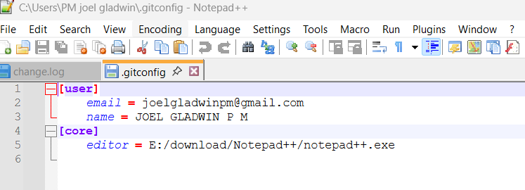

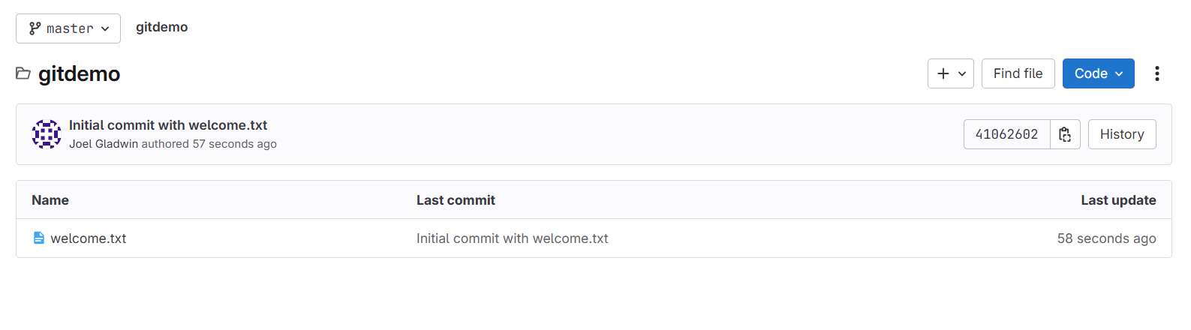

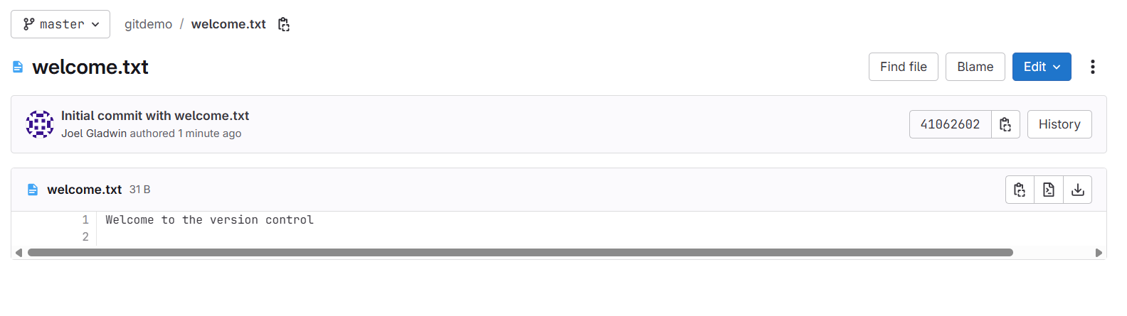

**Filename: 2. Git-HOL**

PM joel gladwin@LAPTOP-PLI2CAPP MINGW64 /e/GitDemo (master)

$ echo "This is a log file" > error.log

mkdir log

echo "Log folder file" > log/temp.log

PM joel gladwin@LAPTOP-PLI2CAPP MINGW64 /e/GitDemo (master)

$ touch .gitignore

PM joel gladwin@LAPTOP-PLI2CAPP MINGW64 /e/GitDemo (master)

$ np .gitignore

PM joel gladwin@LAPTOP-PLI2CAPP MINGW64 /e/GitDemo (master)

$ git status

On branch master

Your branch is up to date with 'origin/master'.

Untracked files:

(use "git add <file>..." to include in what will be committed)

.gitignore

nothing added to commit but untracked files present (use "git add" to track)

PM joel gladwin@LAPTOP-PLI2CAPP MINGW64 /e/GitDemo (master)

$ git add .gitignore

PM joel gladwin@LAPTOP-PLI2CAPP MINGW64 /e/GitDemo (master)

$ git commit -m "Added .gitignore to ignore .log files and log folder"

[master 68ce7f3] Added .gitignore to ignore .log files and log folder

1 file changed, 2 insertions(+)

create mode 100644 .gitignore

PM joel gladwin@LAPTOP-PLI2CAPP MINGW64 /e/GitDemo (master)

$ git push

warning: redirecting to https://gitlab.com/joelgladwinpm-group/gitdemo.git/

Enumerating objects: 4, done.

Counting objects: 100% (4/4), done.

Delta compression using up to 8 threads

Compressing objects: 100% (2/2), done.

Writing objects: 100% (3/3), 330 bytes | 330.00 KiB/s, done.

Total 3 (delta 0), reused 0 (delta 0), pack-reused 0 (from 0)

remote:

remote: To create a merge request for master, visit:

remote: https://gitlab.com/joelgladwinpm-group/gitdemo/-/merge_requests/new?merge_request%5Bsource_branch%5D=master

remote:

To https://gitlab.com/joelgladwinpm-group/gitdemo

4106260..68ce7f3 master -> master

**OUTPUT:**

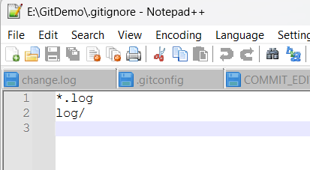

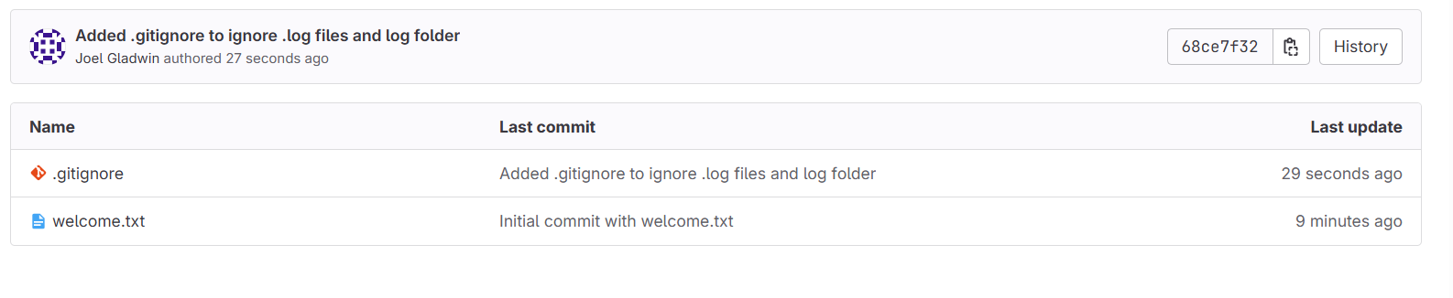

**Filename: 3. Git-HOL**

PM joel gladwin@LAPTOP-PLI2CAPP MINGW64 ~

$ cd E:\GitDemo

PM joel gladwin@LAPTOP-PLI2CAPP MINGW64 /e/GitDemo (master)

$ git checkout -b GitNewBranch

Switched to a new branch 'GitNewBranch'

PM joel gladwin@LAPTOP-PLI2CAPP MINGW64 /e/GitDemo (GitNewBranch)

$ git branch

* GitNewBranch

master

PM joel gladwin@LAPTOP-PLI2CAPP MINGW64 /e/GitDemo (GitNewBranch)

$ echo "This is a branch-specific file" > branchfile.txt

PM joel gladwin@LAPTOP-PLI2CAPP MINGW64 /e/GitDemo (GitNewBranch)

$ cat branchfile.txt

This is a branch-specific file

PM joel gladwin@LAPTOP-PLI2CAPP MINGW64 /e/GitDemo (GitNewBranch)

$ git add branchfile.txt

warning: in the working copy of 'branchfile.txt', LF will be replaced by CRLF the next time Git touches it

PM joel gladwin@LAPTOP-PLI2CAPP MINGW64 /e/GitDemo (GitNewBranch)

$ git commit -m "Added branchfile.txt in GitNewBranch"

[GitNewBranch 2ff1ffc] Added branchfile.txt in GitNewBranch

1 file changed, 1 insertion(+)

create mode 100644 branchfile.txt

PM joel gladwin@LAPTOP-PLI2CAPP MINGW64 /e/GitDemo (GitNewBranch)

$ git status

On branch GitNewBranch

nothing to commit, working tree clean

PM joel gladwin@LAPTOP-PLI2CAPP MINGW64 /e/GitDemo (GitNewBranch)

$ git checkout master

Switched to branch 'master'

Your branch is up to date with 'origin/master'.

PM joel gladwin@LAPTOP-PLI2CAPP MINGW64 /e/GitDemo (master)

$ git config --global diff.tool p4merge

PM joel gladwin@LAPTOP-PLI2CAPP MINGW64 /e/GitDemo (master)

$ git config --global difftool.p4merge.cmd '"C:/Program Files/Perforce/p4merge.exe" "$LOCAL" "$REMOTE"'

PM joel gladwin@LAPTOP-PLI2CAPP MINGW64 /e/GitDemo (master)

$ git config --global merge.tool p4merge

PM joel gladwin@LAPTOP-PLI2CAPP MINGW64 /e/GitDemo (master)

$ git config --global mergetool.p4merge.cmd '"C:/Program Files/Perforce/p4merge.exe" "$BASE" "$LOCAL" "$REMOTE" "$MERGED"'

PM joel gladwin@LAPTOP-PLI2CAPP MINGW64 /e/GitDemo (master)

$ git difftool master GitNewBranch

Viewing (1/1): 'branchfile.txt'

Launch 'p4merge' [Y/n]? y

PM joel gladwin@LAPTOP-PLI2CAPP MINGW64 /e/GitDemo (master)

$ git difftool master GitNewBranch

Viewing (1/1): 'branchfile.txt'

Launch 'p4merge' [Y/n]? Y

PM joel gladwin@LAPTOP-PLI2CAPP MINGW64 /e/GitDemo (master)

$ git difftool --no-prompt master GitNewBranch

PM joel gladwin@LAPTOP-PLI2CAPP MINGW64 /e/GitDemo (master)

$ git checkout master

Already on 'master'

Your branch is up to date with 'origin/master'.

PM joel gladwin@LAPTOP-PLI2CAPP MINGW64 /e/GitDemo (master)

$ echo "" > branchfile.txt

git add branchfile.txt

git commit -m "Dummy branchfile.txt in master for comparison"

warning: in the working copy of 'branchfile.txt', LF will be replaced by CRLF the next time Git touches it

[master 285481c] Dummy branchfile.txt in master for comparison

1 file changed, 1 insertion(+)

create mode 100644 branchfile.txt

PM joel gladwin@LAPTOP-PLI2CAPP MINGW64 /e/GitDemo (master)

$ git difftool master GitNewBranch

Viewing (1/1): 'branchfile.txt'

Launch 'p4merge' [Y/n]? y

PM joel gladwin@LAPTOP-PLI2CAPP MINGW64 /e/GitDemo (master)

$ git checkout master

Already on 'master'

Your branch is ahead of 'origin/master' by 1 commit.

(use "git push" to publish your local commits)

PM joel gladwin@LAPTOP-PLI2CAPP MINGW64 /e/GitDemo (master)

$ git merge GitNewBranch

Auto-merging branchfile.txt

CONFLICT (add/add): Merge conflict in branchfile.txt

Automatic merge failed; fix conflicts and then commit the result.

PM joel gladwin@LAPTOP-PLI2CAPP MINGW64 /e/GitDemo (master|MERGING)

$ git checkout master

branchfile.txt: needs merge

error: you need to resolve your current index first

PM joel gladwin@LAPTOP-PLI2CAPP MINGW64 /e/GitDemo (master|MERGING)

$ git rm branchfile.txt

git commit -m "Removed dummy branchfile.txt from master to avoid conflict"

rm 'branchfile.txt'

[master 89a87cf] Removed dummy branchfile.txt from master to avoid conflict

PM joel gladwin@LAPTOP-PLI2CAPP MINGW64 /e/GitDemo (master)

$ git merge GitNewBranch

Already up to date.

PM joel gladwin@LAPTOP-PLI2CAPP MINGW64 /e/GitDemo (master)

$ git push

warning: redirecting to https://gitlab.com/joelgladwinpm-group/gitdemo.git/

Enumerating objects: 8, done.

Counting objects: 100% (8/8), done.

Delta compression using up to 8 threads

Compressing objects: 100% (5/5), done.

Writing objects: 100% (7/7), 863 bytes | 863.00 KiB/s, done.

Total 7 (delta 1), reused 0 (delta 0), pack-reused 0 (from 0)

remote:

remote: To create a merge request for master, visit:

remote: https://gitlab.com/joelgladwinpm-group/gitdemo/-/merge_requests/new?merge_request%5Bsource_branch%5D=master

remote:

To https://gitlab.com/joelgladwinpm-group/gitdemo

68ce7f3..89a87cf master -> master

PM joel gladwin@LAPTOP-PLI2CAPP MINGW64 /e/GitDemo (master)

$ ls

branchfile.txt error.log **log**/ welcome.txt

PM joel gladwin@LAPTOP-PLI2CAPP MINGW64 /e/GitDemo (master)

$ git push

warning: redirecting to https://gitlab.com/joelgladwinpm-group/gitdemo.git/

Enumerating objects: 4, done.

Counting objects: 100% (4/4), done.

Delta compression using up to 8 threads

Compressing objects: 100% (2/2), done.

Writing objects: 100% (3/3), 384 bytes | 384.00 KiB/s, done.

Total 3 (delta 0), reused 0 (delta 0), pack-reused 0 (from 0)

remote:

remote: To create a merge request for master, visit:

remote: https://gitlab.com/joelgladwinpm-group/gitdemo/-/merge_requests/new?merge_request%5Bsource_branch%5D=master

remote:

To https://gitlab.com/joelgladwinpm-group/gitdemo

89a87cf..68cf6e0 master -> master

**OUTPUT:**

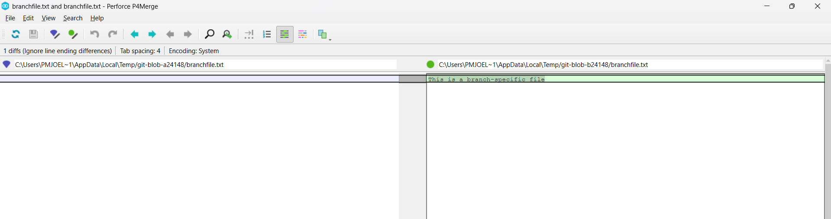

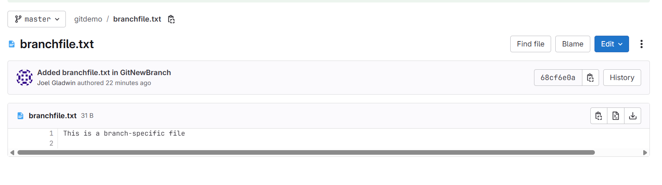

**Filename: 4. Git-HOL**

PM joel gladwin@LAPTOP-PLI2CAPP MINGW64 /e/GitDemo (master)

$ git checkout master

Already on 'master'

Your branch is up to date with 'origin/master'.

PM joel gladwin@LAPTOP-PLI2CAPP MINGW64 /e/GitDemo (master)

$ git status

On branch master

Your branch is up to date with 'origin/master'.

nothing to commit, working tree clean

PM joel gladwin@LAPTOP-PLI2CAPP MINGW64 /e/GitDemo (master)

$ git checkout -b GitWork

Switched to a new branch 'GitWork'

PM joel gladwin@LAPTOP-PLI2CAPP MINGW64 /e/GitDemo (GitWork)

$ echo "<message>Hello from branch</message>" > hello.xml

PM joel gladwin@LAPTOP-PLI2CAPP MINGW64 /e/GitDemo (GitWork)

$ git add hello.xml

warning: in the working copy of 'hello.xml', LF will be replaced by CRLF the next time Git touches it

PM joel gladwin@LAPTOP-PLI2CAPP MINGW64 /e/GitDemo (GitWork)

$ git commit -m "Added hello.xml in GitWork"

[GitWork 025b552] Added hello.xml in GitWork

1 file changed, 1 insertion(+)

create mode 100644 hello.xml

PM joel gladwin@LAPTOP-PLI2CAPP MINGW64 /e/GitDemo (GitWork)

$ git checkout master

Switched to branch 'master'

Your branch is up to date with 'origin/master'.

PM joel gladwin@LAPTOP-PLI2CAPP MINGW64 /e/GitDemo (master)

$ echo "<message>Hello from master</message>" > hello.xml

PM joel gladwin@LAPTOP-PLI2CAPP MINGW64 /e/GitDemo (master)

$ git add hello.xml

warning: in the working copy of 'hello.xml', LF will be replaced by CRLF the next time Git touches it

PM joel gladwin@LAPTOP-PLI2CAPP MINGW64 /e/GitDemo (master)

$ git commit -m "Added hello.xml in master"

[master b266f7e] Added hello.xml in master

1 file changed, 1 insertion(+)

create mode 100644 hello.xml

PM joel gladwin@LAPTOP-PLI2CAPP MINGW64 /e/GitDemo (master)

$ git log --oneline --graph --decorate --all

* b266f7e (**HEAD** -> **master**) Added hello.xml in master

| * 025b552 (**GitWork**) Added hello.xml in GitWork

|/

* 68cf6e0 (**origin/master**) Added branchfile.txt in GitNewBranch

* 89a87cf Removed dummy branchfile.txt from master to avoid conflict

|\

| * 2ff1ffc (**GitNewBranch**) Added branchfile.txt in GitNewBranch

* | 285481c Dummy branchfile.txt in master for comparison

|/

* 68ce7f3 Added .gitignore to ignore .log files and log folder

* 4106260 Initial commit with welcome.txt

PM joel gladwin@LAPTOP-PLI2CAPP MINGW64 /e/GitDemo (master)

$ git merge GitWork

Auto-merging hello.xml

CONFLICT (add/add): Merge conflict in hello.xml

Automatic merge failed; fix conflicts and then commit the result.

PM joel gladwin@LAPTOP-PLI2CAPP MINGW64 /e/GitDemo (master|MERGING)

$ git mergetool

Merging:

hello.xml

Normal merge conflict for 'hello.xml':

{local}: created file

{remote}: created file

PM joel gladwin@LAPTOP-PLI2CAPP MINGW64 /e/GitDemo (master|MERGING)

$ git add hello.xml

git commit -m "Resolved conflict in hello.xml between master and GitWork"

[master d4baa70] Resolved conflict in hello.xml between master and GitWork

**OUTPUT:**

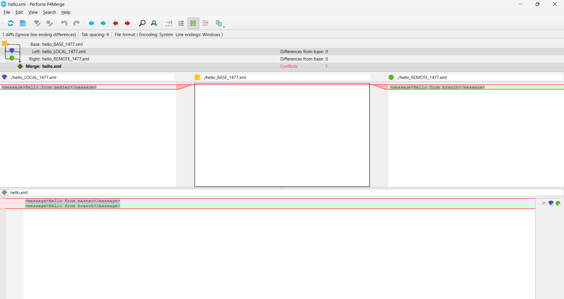

**Filename: 5. Git-HOL**

PM joel gladwin@LAPTOP-PLI2CAPP MINGW64 /e/GitDemo (master)

$ git checkout master

Already on 'master'

Your branch is up to date with 'origin/master'.

PM joel gladwin@LAPTOP-PLI2CAPP MINGW64 /e/GitDemo (master)

$ git status

On branch master

Your branch is up to date with 'origin/master'.

nothing to commit, working tree clean

PM joel gladwin@LAPTOP-PLI2CAPP MINGW64 /e/GitDemo (master)

$ git branch

* master

PM joel gladwin@LAPTOP-PLI2CAPP MINGW64 /e/GitDemo (master)

$ git pull origin master

warning: redirecting to https://gitlab.com/joelgladwinpm-group/gitdemo.git/

From https://gitlab.com/joelgladwinpm-group/gitdemo

* branch master -> FETCH_HEAD

Already up to date.

PM joel gladwin@LAPTOP-PLI2CAPP MINGW64 /e/GitDemo (master)

$ git push origin master

warning: redirecting to https://gitlab.com/joelgladwinpm-group/gitdemo.git/

Everything up-to-date

**OUTPUT:**

